Browser Object Model

The **Browser Object Model** (BOM) is used to interact with the browser.

The default object of browser is window means you can call all the functions of window by specifying window or directly. For example:

window.alert("hello nareshit");

is same as:

alert("hello nareshit");

You can use a lot of properties (other objects) defined underneath the window object like document, history, screen, navigator, location, innerHeight, innerWidth,

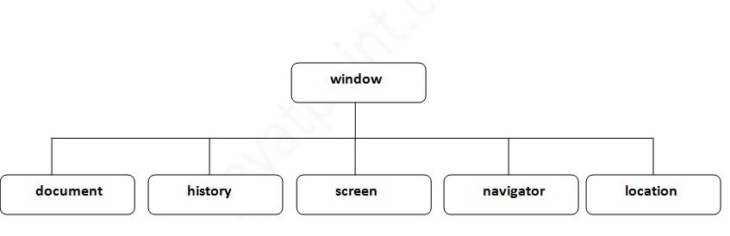

Window Object

The **window object** represents a window in browser. An object of window is created automatically by the browser.

Window is the object of browser, **it is not the object of javascript**. The javascript objects are string, array, date etc.

## **Methods of window object**

The important methods of window object are as follows:

|  |  |
| --- | --- |
| **Method** | **Description** |
| alert() | displays the alert box containing message with ok button. |
| confirm() | displays the confirm dialog box containing message with ok and cancel button. |
| prompt() | displays a dialog box to get input from the user. |
| open() | opens the new window. |
| close() | closes the current window. |
| setTimeout() | performs action after specified time like calling function, evaluating expressions etc. |

#### **Example of alert() in javascript**

It displays alert dialog box. It has message and ok button.

**<script** type="text/javascript"**>**

function msg(){

 alert("Hello Alert Box");

}

**</script>**

**<input** type="button" value="click" onclick="msg()"**/>**

#### **Example of confirm() in javascript**

It displays the confirm dialog box. It has message with ok and cancel buttons.

**<script** type="text/javascript"**>**

function msg(){

var v= confirm("Are u sure?");

if(v==true){

alert("ok");

}

else{

alert("cancel");

}

}

**</script>**

**<input** type="button" value="delete record" onclick="msg()"**/>**

#### **Example of prompt() in javascript**

It displays prompt dialog box for input. It has message and textfield.

**<script** type="text/javascript"**>**

function msg(){

var v= prompt("Who are you?");

alert("I am "+v);

}

**</script>**

**<input** type="button" value="click" onclick="msg()"**/>**

#### **Example of open() in javascript**

It displays the content in a new window.

**<script** type="text/javascript"**>**

function msg(){

open("http://www.nareshit.com");

}

**</script>**

**<input** type="button" value="nareshit" onclick="msg()"**/>**

#### **Example of setTimeout() in javascript**

It performs its task after the given milliseconds.

**<script** type="text/javascript"**>**

function msg(){

setTimeout(

function(){

alert("Welcome to nareshit after 2 seconds")

},2000);

}

**</script>**

**<input** type="button" value="click" onclick="msg()"**/>**

JavaScript History Object

The **JavaScript history object** represents an array of URLs visited by the user. By using this object, you can load previous, forward or any particular page.

The history object is the window property, so it can be accessed by:

window.history

Or,

history

## **Property of JavaScript history object**

There are only 1 property of history object.

|  |  |  |
| --- | --- | --- |
| **No.** | **Property** | **Description** |
| 1 | length | returns the length of the history URLs. |

## **Methods of JavaScript history object**

There are only 3 methods of history object.

|  |  |  |
| --- | --- | --- |
| **No.** | **Method** | **Description** |
| 1 | forward() | loads the next page. |
| 2 | back() | loads the previous page. |
| 3 | go() | loads the given page number. |

## **Example of history object**

Let’s see the different usage of history object.

history.back();//for previous page

history.forward();//for next page

history.go(2);//for next 2nd page

history.go(-2);//for previous 2nd page

JavaScript Navigator Object

The **JavaScript navigator object** is used for browser detection. It can be used to get browser information such as appName, appCodeName, userAgent etc.

The navigator object is the window property, so it can be accessed by:

1. window.navigator

Or,

1. navigator

## **Property of JavaScript navigator object**

There are many properties of navigator object that returns information of the browser.

|  |  |  |
| --- | --- | --- |
| **No.** | **Property** | **Description** |
| 1 | appName | returns the name |
| 2 | appVersion | returns the version |
| 3 | appCodeName | returns the code name |
| 4 | cookieEnabled | returns true if cookie is enabled otherwise false |
| 5 | userAgent | returns the user agent |
| 6 | language | returns the language. It is supported in Netscape and Firefox only. |
| 7 | userLanguage | returns the user language. It is supported in IE only. |
| 8 | plugins | returns the plugins. It is supported in Netscape and Firefox only. |
| 9 | systemLanguage | returns the system language. It is supported in IE only. |
| 10 | mimeTypes[] | returns the array of mime type. It is supported in Netscape and Firefox only. |
| 11 | platform | returns the platform e.g. Win32. |
| 12 | online | returns true if browser is online otherwise false. |

## **Methods of JavaScript navigator object**

The methods of navigator object are given below.

|  |  |  |
| --- | --- | --- |
| **No.** | **Method** | **Description** |
| 1 | javaEnabled() | checks if java is enabled. |
|  |  |  |

#### **Example of navigator object**

Let’s see the different usage of navigator object.

**<script>**

document.writeln("**<br/>**navigator.appCodeName: "+navigator.appCodeName);

document.writeln("**<br/>**navigator.appName: "+navigator.appName);

document.writeln("**<br/>**navigator.appVersion: "+navigator.appVersion);

document.writeln("**<br/>**navigator.cookieEnabled: "+navigator.cookieEnabled);

document.writeln("**<br/>**navigator.language: "+navigator.language);

document.writeln("**<br/>**navigator.userAgent: "+navigator.userAgent);

document.writeln("**<br/>**navigator.platform: "+navigator.platform);

document.writeln("**<br/>**navigator.onLine: "+navigator.onLine);

**</script>**

JavaScript Screen Object

The **JavaScript screen object** holds information of browser screen. It can be used to display screen width, height, colorDepth, pixelDepth etc.

The screen object is the window property, so it can be accessed by:

1. window.screen

Or,

1. screen

## **Property of JavaScript Screen Object**

There are many properties of screen object that returns information of the browser.

|  |  |  |
| --- | --- | --- |
| **No.** | **Property** | **Description** |
| 1 | Width | returns the width of the screen |
| 2 | Height | returns the height of the screen |
| 3 | availWidth | returns the available width |
| 4 | availHeight | returns the available height |
| 5 | colorDepth | returns the color depth |
| 6 | pixelDepth | returns the pixel depth. |

#### **Example of JavaScript Screen Object**

Let’s see the different usage of screen object.

**<script>**

document.writeln("**<br/>**screen.width: "+screen.width);

document.writeln("**<br/>**screen.height: "+screen.height);

document.writeln("**<br/>**screen.availWidth: "+screen.availWidth);

document.writeln("**<br/>**screen.availHeight: "+screen.availHeight);

document.writeln("**<br/>**screen.colorDepth: "+screen.colorDepth);

document.writeln("**<br/>**screen.pixelDepth: "+screen.pixelDepth);

**</script>**

Document Object Model

The **document object** represents the whole html document.

When html document is loaded in the browser, it becomes a document object. It is the **root element** that represents the html document. It has properties and methods. By the help of document object, we can add dynamic content to our web page.

As mentioned earlier, it is the object of window. So

1. window.document

Is same as document

## **Properties of document object**

properties of document object that can be accessed and modified by the document object.

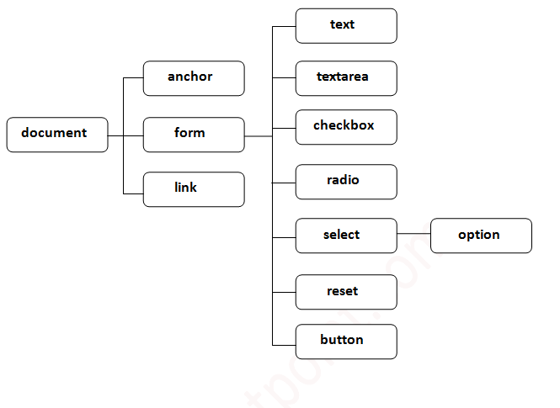

## **Methods of document object**

We can access and change the contents of document by its methods.

The important methods of document object are as follows:

|  |  |
| --- | --- |
| **Method** | **Description** |
| write("string") | writes the given string on the doucment. |
| writeln("string") | writes the given string on the doucment with newline character at the end. |
| getElementById() | returns the element having the given id value. |
| getElementsByName() | returns all the elements having the given name value. |
| getElementsByTagName() | returns all the elements having the given tag name. |
| getElementsByClassName() | returns all the elements having the given class name. |